15CSE376 Net Centric Programming

Term 1 Project Evaluation

I Page 1

Review Term:

Group Number:

Reg Nos:

Names:

Project Title:

II Page 2

Abstract: Write up about the need for the project, overall modules and their functionalities

III Pages 3-5

Introduction to Web Designing: Technologies for handling the design – Write up on HTML5,CSS, JS – Frameworks used for UI Development

**IV Pages 6-8**

**System Requirements Specifications**

**Design Diagram (Main modules and sub modules in each page)**

**Sample:**

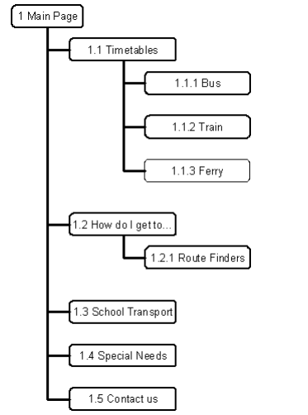

**V (Pages 9-18)**

**Implementation (Not more than 10 pages… if project has more web pages include specification of most important pages only)**

**No of pages depends on the students effort….**

**For each web page used in the project (expected minimum 2 per student)**

Screenshot of the page

Description (Purpose in not more than 2 paragraphs): The Train Timetable screen enables the user to specify a rail line and day of week.

Elements used in the page: Field name, GUI Control used, Validation rule applied, Any specific Feature (mention only if element is dynamic)

Code Snippets to illustrate special UI features(HTML5,CSS, JS) used in the design (not more than 3 pages in total – Do not include Full code)

**VI Testing (Include rows for key fields ….. Pages 19)**

(Make a table)

|  |  |  |  |
| --- | --- | --- | --- |
| Field | Input Given | Success/Failure | Reason for Failure |
|  |  |  |  |
|  |  |  |  |

**VII Page 20 (Evaluation Sheet)**

|  |  |  |  |
| --- | --- | --- | --- |
| Roll No | Technology | Max Marks | Marks Awarded |
|  | HTML  CSS  JS  Viva | 10  10  10  10 |  |
|  | HTML  CSS  JS  Viva | 10  10  10  10 |  |
|  | HTML  CSS  JS  Viva | 10  10  10  10 |  |
|  | HTML  CSS  JS  Viva | 10  10  10  10 |  |
|  | Project Documentation | 10 |  |
|  | Total | 50 |  |

Instructions to students:

Students are to submit Hard and soft copy (.pdf) of the report – 1 per each project group

Students are to bring the copy of the evaluation sheet bound along with the project report (in stick file) for the award of marks.